

Day for Palestine

[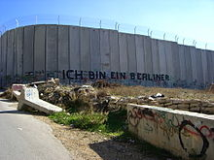](http://en.wikipedia.org/wiki/File:Israel-Palestinian_Wall_Ich_Bin_Eine_Berliner.jpg)

SAT FEB 28th 12am – 5pm

St. Swithuns Church Community Centre,

105 Waverley Rd, Southsea PO5 2PL

12 am: Palestine & Sport - Red Card Israeli Racism Gareth Edwards (Lecturer in Sports History)

1 pm: Lunch (Free Palestinian food)

2 pm: Health & Education in Palestine

Aimee Shalan (Director at Friends of Birzeit University)

3 pm: Why is Gaza Blockaded?

Kevin Ovenden (Viva Palestina Organiser)

4 pm: BDS - The Way Forward

Salim Alam (PSC Campaigns Director)

Free entry, all welcome

For further info contact Jenny Flintoft, flintoftjenifer@yahoo.co.uk